



Ed-Fi to Generate

ETL Plug-In Documentation

aemcorp.com/education

AUGUST | 2018

Contents

Introduction 3

Analysis 3

Conclusion 5

|  |  |  |
| --- | --- | --- |
| **Version History** | | |
| **Version #** | **Author(s)** | **Version Date** |
| 1.0 | Nathan Clinton | 8/31/2018 |
|  |  |  |
|  |  |  |

# Introduction

In this document we review the performance of the Ed-Fi ODS when applying the Generate ETL scripts. We utilized the SQL Server Performance Tuner to analyze the structure, partitions, indexes, and statistics of the Glendale database. An execution of all the SELECT statements in the Generate ETL code served as the workload for the analysis. The threshold for required performance tuning for the Ed-Fi ODS was an execution time of five minutes or greater or a performance gain of 10% or greater.

# Analysis

The SQL Server Performance Tuner approximated a 4% performance gain from the recommended statistics and index. No schema or partition changes were recommended. The SQL workload was able to run within 31 seconds, returning 1,182,447 reords. Details of the performance tuning execution are listed below.

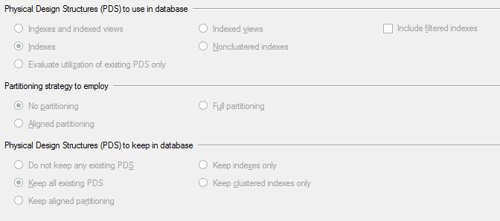

Figure - Performance Tuning Options Selected

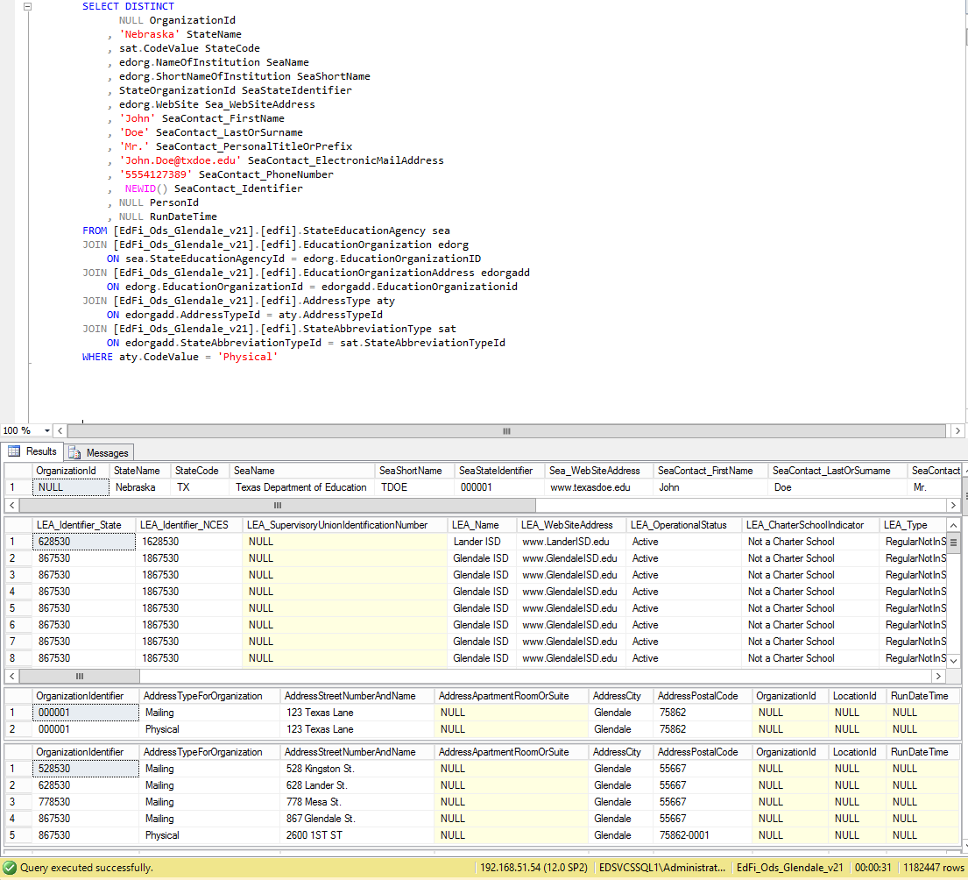

Figure - SQL Workload Execution Speed

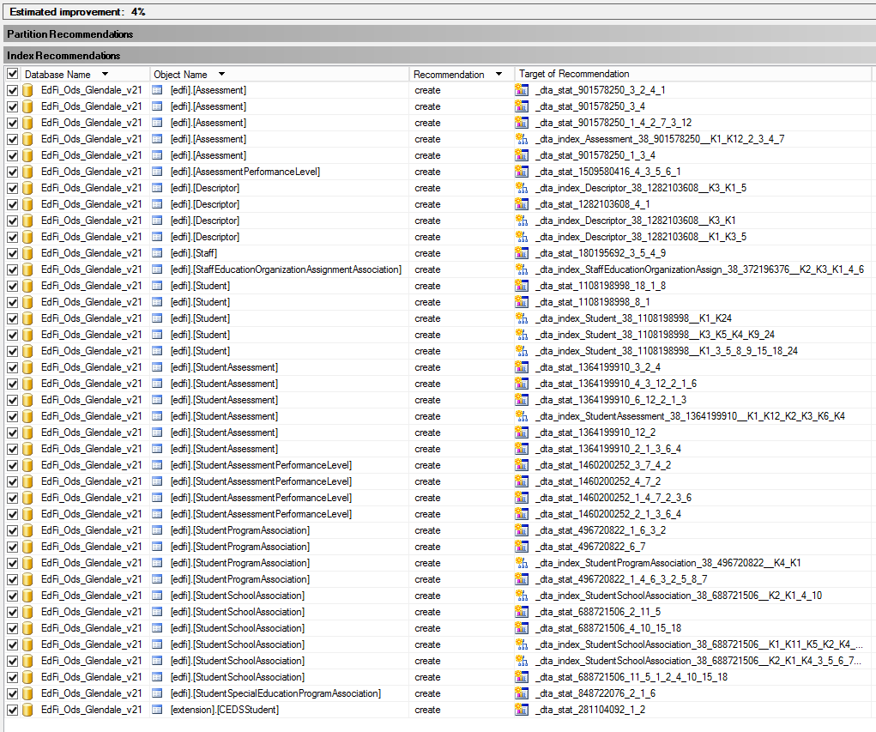

Figure - SQL Server Performance Tuner Recommendations and Estimated Improvement

# Conclusion

We do not recommend any changes to the schema, partitions, statistics, or indexes at this time. The performance gains would not outweigh the cost of increased storage usage. However, because of the relatively small dataset in the Glendale database, we recommend performing this performance analysis again when a larger dataset (preferably 200,000 students or more) becomes available. The SQL Server Performance Tuner recommended scripts have been saved to the BitBucket repository along with this analysis for review, as well as the SQL script used as the workload for the analysis.